**Ideation Phase**

**Empathize & Discover**

|  |  |
| --- | --- |
| Date: | 19 June 2025 |
| Team ID: | LTVIP2025TMID36354 |
| Project Name: | Enchanted Wings: Marvels of Butterfly Species |
| Maximum Marks: | 4 Marks |

# Butterfly Species Classification using Transfer Learning:

Butterfly species identification plays a crucial role in biodiversity conservation, environmental monitoring, and ecological research. Due to the vast number of butterfly species and the visual similarity between many of them, manual identification can be slow, difficult, and require expert knowledge.  
  
Using AI and machine learning, especially transfer learning models like VGG16, this project enables faster and more accurate classification of butterfly images. This provides real-time support for researchers, field biologists, educators, and even the general public involved in citizen science initiatives.

This solution aims to empower various stakeholders by enabling accurate image-based identification of butterflies, promoting conservation awareness, and supporting scientific research. With rising interest in biodiversity and climate change, this system ensures scalable, efficient, and accessible monitoring of butterfly species in different habitats.

Hence, there is a need to develop robust ML models capable of predicting butterfly species with high precision using limited data, leveraging transfer learning to reduce training time while improving model accuracy.

# 🎯 Target User: Nature Enthusiast / Field Researcher

## 🗣️ 1. Says

* “I wish there was an easier way to identify butterflies in the wild.”
* “I'm not sure what species this is.”
* “I want to contribute to conservation, but I’m not an expert.”

## 💭 2. Thinks

* “Am I classifying this species correctly?”
* “Will this help researchers or scientists?”
* “What if I make a mistake while identifying the butterfly?”

## **🧍 3. Does**

* Takes photos of butterflies in natural habitats
* Tries searching online or in books for identification
* Participates in biodiversity campaigns or school projects

## ❤️ 4. Feels

* Curious and enthusiastic about nature
* Frustrated with the difficulty of manual identification
* Empowered when able to identify a butterfly correctly

## 👀 5. Sees

* Complex classification charts and species guides
* Inconsistent or incomplete online results
* Scientific names that are hard to remember

## 👂 6. Hears

* Peers and teachers encouraging citizen science
* Researchers discussing biodiversity and conservation
* Comments about how hard it is to tell species apart

## 🎁 7. Gains

* Learns species names quickly with app help
* Feels included in scientific contribution
* Spreads awareness through education and participation

## 😣 8. Pains

* Misidentifying a species
* Low-quality images leading to inaccurate predictions
* 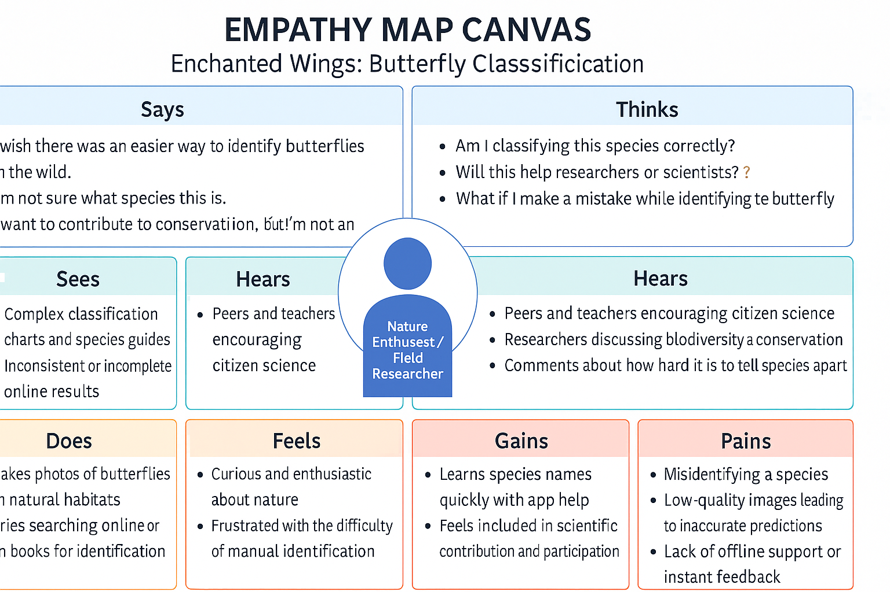Lack of offline support or instant feedback